Message for Lighthouse CC 18th August 2013

Seeing the World as God Does
Read Isaiah 61:1-6

1 All People are God’s People –
  - He is the God of the whole earth!
  - Other people are our brothers and sisters!
  - There is no room for discrimination!
  - God Loves them All

2 All People are tainted with sin

Poor, diseased, bondage, deception – lost, corrupted etc

The love of money is the root of all evil (1 Tim. 6:10)

They all need a saviour - The only answer is Christ and His Gospel

3 We are very privileged in Australia ! – The “Lucky Country”

We have one of the highest GDP’s per capita in the world

Yet our teenage suicides are one of the highest in the world

Our marriage/family break-downs is one of the highest in the world

We complain about the Environment, Energy, Water. Poverty, Terrorism and War, Disease, Education, Democracy. Population etc!

We suffer from the 3 biggest drug problems

Alcohol

Alcohol

Alcohol !

How Poor We Really Are
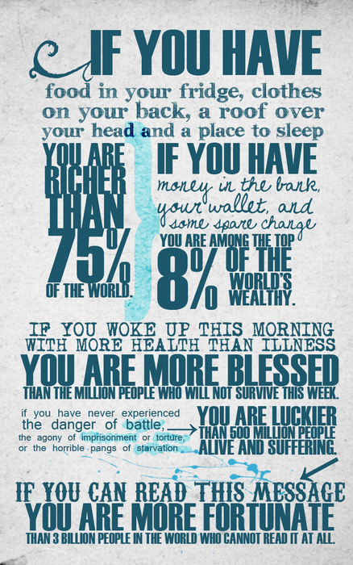

One day a wealthy family man took his son on a trip to the country so he could have his son see how poor country people were. They stayed one day and one night in the farmhouse of a very humble farm. On the way back home at the end of the trip the father asked the son, 'What did you think of the trip?'
The son replied, 'Very nice, Dad.'
The father then asked, 'Did you noticed how poor they were?'
The son replied, 'Yes, I guess so.'
The father then added, 'And what did you learn?'
To this question, the son thought for a moment and answered slowly, 'I learned that we have one dog in the house and they have four. We have a fountain in the garden and they have a stream that has no end.
'We have fancy lanterns in our garden, while they have the stars. Our garden goes to the edge of our yard, but for their back yard they have the entire horizon!' At the end of the son's reply, the rich father was speechless. His son then added: 'Thanks, Dad, for showing me how poor we really are.'

The “Lucky Country”
- Because of Our Judeo-Christian Heritage !
- We have a great responsibility to help the needy and share the good news.
  - To who much is given.... much is required (Luke 12:48)
- We need to Note:
  - Remember then, it is the LORD, your God, who gives you the power to acquire wealth, by fulfilling, as he has now done, the covenant which he swore to your fathers.But if you forget the LORD, your God, and follow other gods, serving and worshiping them, I forewarn you this day that you will perish utterly.Like the nations which the LORD destroys before you, so shall you too perish for not heeding the voice of the LORD, your God.(Deu_8:18 )

Joshua’s Charge to Israel – God’s Charge to you!
- “I gave you a land which you had not tilled and cities which you had not built, to dwell in; you have eaten of vineyards and olive groves which you did not plant.
- “Now, therefore, fear the LORD and serve him completely and sincerely. Cast out the gods your fathers served beyond the River and in Egypt, and serve the LORD.
- If it does not please you to serve the LORD, decide today whom you will serve, the gods your fathers served beyond the River or the gods of the Amorites in whose country you are dwelling. But as for me and my household, we will serve the LORD.” (Josh.24)

Questions for Discussion
- How easily do you accept the fact that “All People are God’s People”? (in other words people from other ethnic backgrounds are your brothers and sisters)
- How do you feel about the Scripture that says The love of money is the root of all evil (1 Tim. 6:10)
- How does money contribute to one’s happiness and sense of fulfilment?
- Why do you feel that people from poor countries seem happier than us in Australia who enjoy such comparative wealth?
- What is the real answer to finding true fulfilment in life?

